**What is angular-?**

Angular is a structural framework for developing dynamic web apps. It allows developers to use HTML as a template language and allows HTML's syntax to express the application's components briefly and clearly.

Why angular?

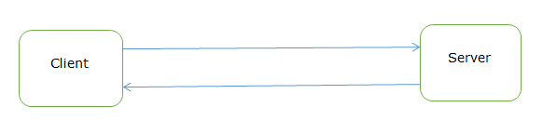

When we sent the request from browser, then it will go to server, every time when we sent the request for data, the whole page is loaded again and again, so it takes lot of time to rendering or load the pages, also performance of application will be down.

That is called as multi page application

Angular is the single page application?

It means load the single page and dynamically update the page.

You can take the example of gmail application. It will loads the single page first then you click on sent item or mail item at that time it will request the specific components. That is called as SPA.

Why angular is so popular?

It is easy to use

Provides the MVC architecture

It is compatible for both desktop and mobile application.

Two way binding

Provides the filter facility

Advantages-

It does not depend upon backend to load the HTML pages.

Easy to debug in browser

To overcome this problem, angular comes into picture.

**How to download and install Angular-**

We need Visual Studio code software to write the angular code.

Go to official sites <https://code.visualstudio.com/download>

Download the visual studio on machine.

Download the node.js <https://nodejs.org/en/download/>

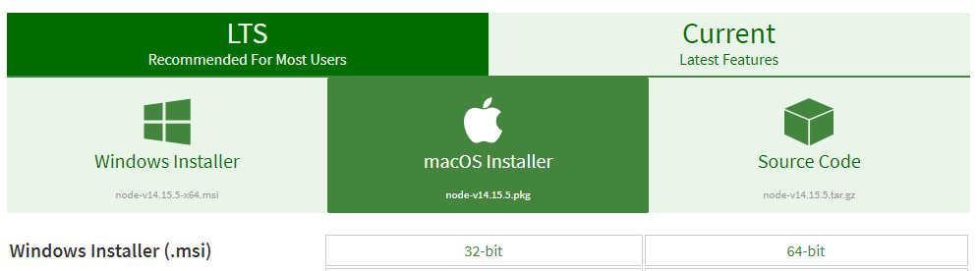

Go to windows Installer, click on 64 bit installer.

Right click on the downloaded file -> click on Install option

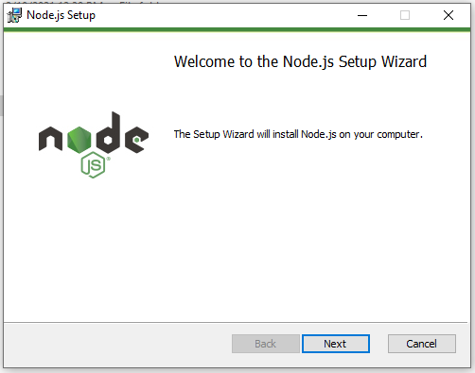

Click on Next button

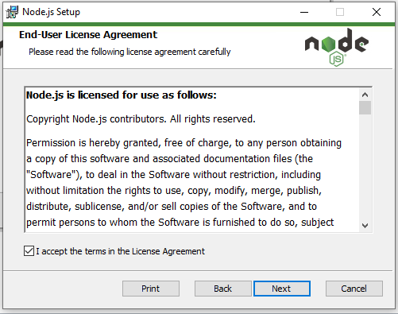

Click the checkbox I accept the terms in the license agreement then click on Next button.

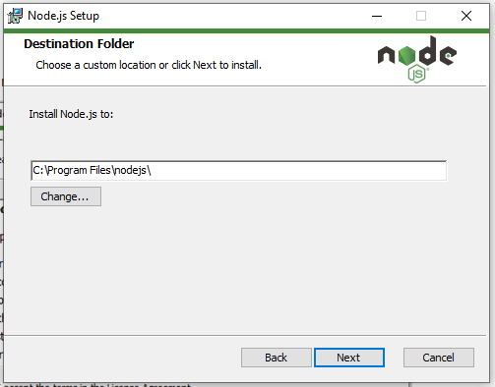

Click on Next button

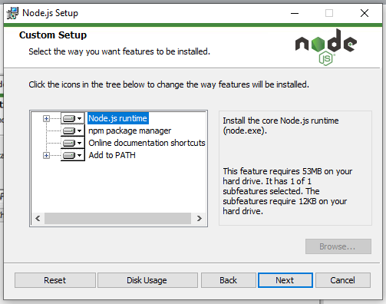

Click on Next button

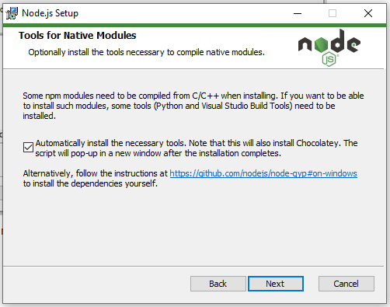

Click on checkbox then Next button.

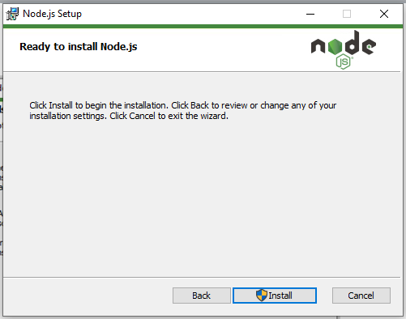

Click on Install button

Do you want to allow this app to make changes select as yes button.

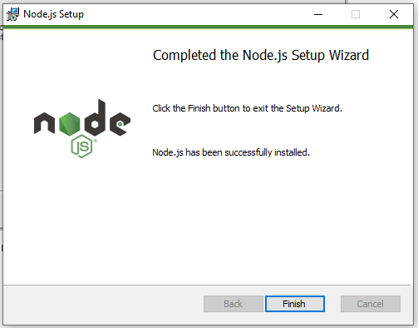

Click on finish button.

Then command prompt pop up appears just close it.

Again open the command prompt, type cmd in search box

Type node -v

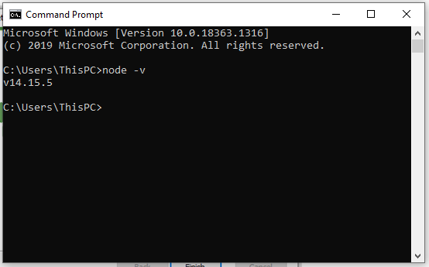

Will see the node version- v14.15.5 it mean node.js has been successfully installed on your machine.

**How to download visual studio code?**

Go to https://code.visualstudio.com/download

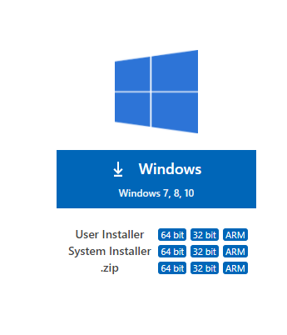

Select windows-> user installer as 64 bit (According to pc)

It will take some time to download the visual studio code software.

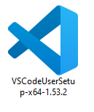

Double click on it to install the software on machine.

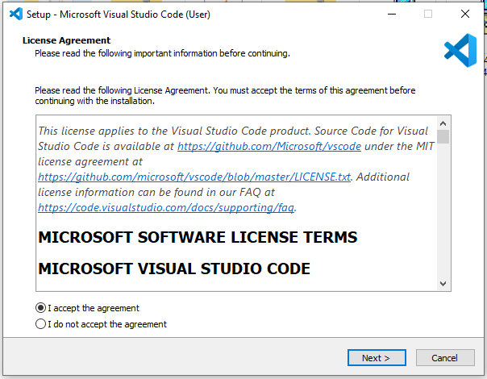

Click on Next button.

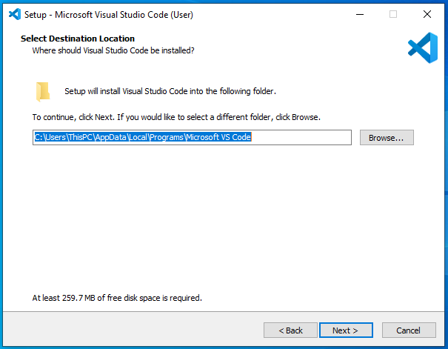

Click on Next button

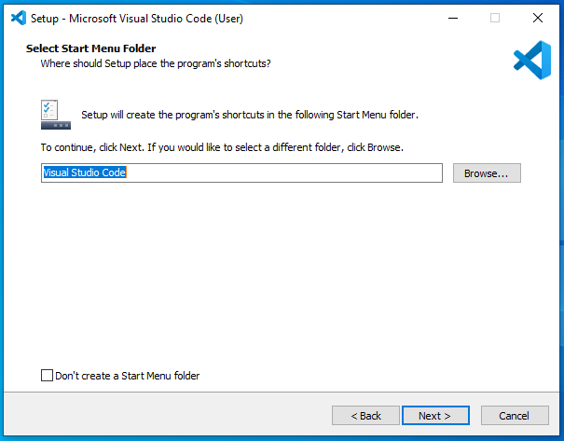

Click on Next button

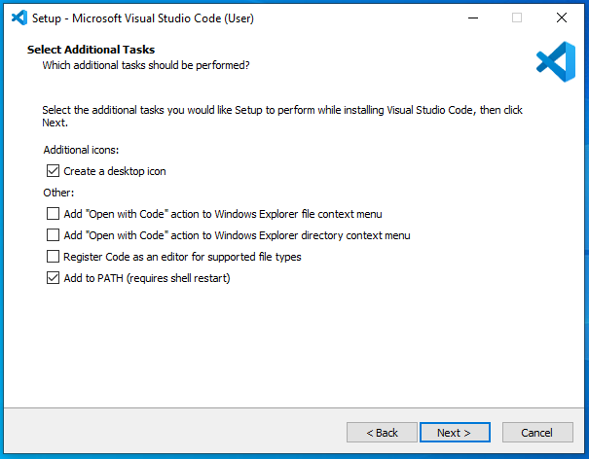

Click on create desktop icon and next button.

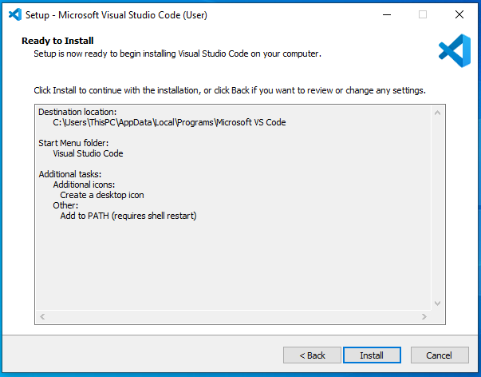

Click on install button.

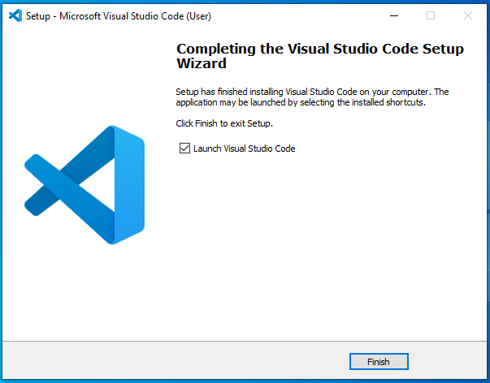

Click on finish button.